Canopia
  - Local experience discovery for the hackathon
Canopia helps hotels understand the people behind a reservation. A natural pre-arrival conversation becomes a practical brief with room preparation, service adaptations, thoughtful touches and relevant paid-service ideas, shaped by the hotel’s identity, know-how and limits.
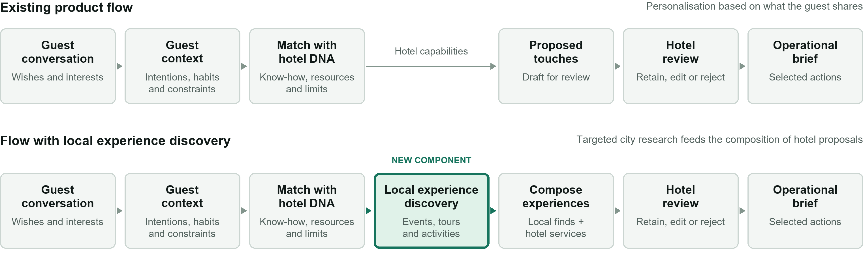
DNA guides discovery and final composition. Local research runs when relevant; the hotel reviews options before any offer or booking.

What the component does
Searches venue calendars, ticketing platforms, tour listings and local directories for the stay dates. Filters by guest interests, pace and constraints. Returns practical details and helps combine suitable activities with the hotel’s services.

Expected value
Less initial research for the concierge and more complete proposals for the guest. The hotel can add transport, a guide, dining or personal touches, confirm delivery, and set its own final price and margin.

What the hackathon should prove
For one city and a fixed stay, produce two or three sourced options. Compare them with the existing brief: fit for the guest, usable booking information and a coherent itinerary the hotel can assess. Show unresolved checks.

Illustrative example Interest in art → a relevant exhibition during the stay → hotel pickup, a visit and a dinner matched to the guest.
Test boundaries Dates and sources recorded · availability status explicit · no automatic booking · hotel confirms feasibility and final price.
Existing foundation: local app, six hotel DNA profiles, conversations and editable briefs. Local discovery and source connections are to be built.
Hackathon option 2 · Once Upon a Stay · Experimental component; adoption into Canopia remains to be decided.

Examples and repository guide
Appendix for the hackathon team
Private repository crosojulien-spec/canopia | GitHub main at d76be5c | Checked 6 October 2026

From a listing to a hotel experience
Illustrative concepts only. Actual venues, times, prices and availability must be checked for the selected stay.

01 An art evening
Guest cue: contemporary art and a relaxed dinner. Find an exhibition or opening during the stay. Draft sequence: 17:30 hotel pickup → 18:00 gallery → 19:45 dinner. Match the restaurant to the guest’s tastes; check travel time and whether a driver or guide can be arranged.

02 A food discovery afternoon
Find a market visit or small-group food tour suited to the guest’s pace, language and food preferences. Add hotel transport or a relevant dinner where useful. Record the meeting point, walking requirements, duration and what the ticket includes.

The information the concierge receives
Guest fit and logistics: why it fits, exact dates and slots, location, duration, travel time and constraints.
Booking and costs: source and check time, booking link or contact, price and currency, per-person or group basis, inclusions and cancellation terms. Separate advertised availability from confirmed availability; label anything unknown.
Hotel composition: suggested transport, guide, dining or personal touches; who would arrange each element and what remains to confirm.

How the hotel turns it into an offer
Keep external prices separate from hotel service costs and markup. The hotel chooses the package, confirms suppliers and availability, then sets the final guest price. If no suitable option is reliable, return the gap as a concierge research task.

Where to find what in Git

01 Product scope and local setup
README · Product decisions
Start with guest discovery, hotel authority and local setup. The core product currently gives the concierge research tasks.

02 Guest inputs and AI instructions
server/ai.ts · prompts/
See how reservation details, hotel DNA and the transcript feed the conversation and brief. Derive the local search request from these inputs.

03 Hotel capabilities and limitations
data/dna/ · Review guide
Six profiles, composition examples, sources and unresolved checks. Use them to assess possible hotel additions without assuming operational approval.

04 Proposal composition and lifecycle
Brief prompt · server/service.ts
Read the brief structure, role routing, generation and versioning. External findings need to feed proposals before human review.

05 Data structures to extend
shared/types.ts
ResearchExtensionProposal is an existing starting pattern for sources, confirmations and selection. Local listings, booking details and price fields still need defining.

06 Baseline conversations and briefs
Conversation evaluations · Test review
Use saved transcripts, generated briefs and review notes to understand the baseline. These fictional test stays are not field validation.

Repository snapshot Links target the verified GitHub commit. The repository provides the core product and a research contract; this local discovery option, its external source connections and its booking-data fields are not implemented.

